Q1 | Create two tables: Influencers (id, name) and Collaborations (id, influencer1_id, influencer2_id, collab_date). Write a SQL FULL JOIN query to list all influencers and show their collaboration partner names if any, including influencers with no collaborations.
Code | #create table influencers and insert record  CREATE TABLE Influencers ( id INT AUTO_INCREMENT, name VARCHAR(100), PRIMARY KEY(id) );  INSERT INTO Influencers VALUES (1, 'Mayank'), (2, 'Disha'), (3, 'Khushi'), (4, 'Dipti');  ##create table collaborations and insert record  CREATE TABLE Collaborations ( id INT AUTO_INCREMENT, influencer1_id INT, influencer2_id INT, collab_date DATE, PRIMARY KEY(id) );  INSERT INTO Collaborations VALUES (1, 1, 2, '2026-01-10'), (2, 2, 3, '2026-02-15');  #Insert final code  SELECT i1.name AS influencer_name, i2.name AS collaboration_partner, c.collab_date FROM Collaborations c LEFT JOIN Influencers i1 ON c.influencer1_id = i1.id LEFT JOIN Influencers i2 ON c.influencer2_id = i2.id UNION SELECT i1.name AS influencer_name, i2.name AS collaboration_partner, c.collab_date FROM Collaborations c RIGHT JOIN Influencers i1 ON c.influencer1_id = i1.id LEFT JOIN Influencers i2 ON c.influencer2_id = i2.id;
Output | 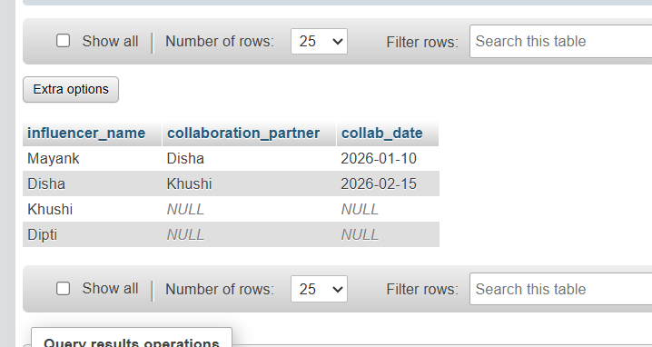

Q2 | Using a SELF JOIN, write a query on a table called Playlists (id, user_id, playlist_name, parent_playlist_id) to display each playlist alongside its parent playlist name, similar to how Spotify shows nested playlists.<br><br><em><strong>Hint:</strong> Join Playlists with itself on parent_playlist_id = id.</em>
Code | #create table playlists  CREATE TABLE Playlists ( id INT PRIMARY KEY, user_id INT, playlist_name VARCHAR(100), parent_playlist_id INT );  #insert data  INSERT INTO Playlists (id, user_id, playlist_name, parent_playlist_id) VALUES (1, 101, 'Music', 2), (2, 101, 'Rock', 1), (3, 101, 'Pop', 1), (4, 102, 'Workout', 5), (5, 102, 'Cardio', 4);  #final code  SELECT p1.id AS Playlist_ID, p1.playlist_name AS Playlist_Name, p2.playlist_name AS Parent_Playlist_Name FROM Playlists p1 LEFT JOIN Playlists p2 ON p1.parent_playlist_id = p2.id;
Output | 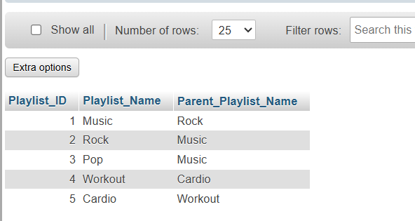

Q3 | Given three tables: Users (id, username), Orders (id, user_id, order_date), and Payments (id, order_id, amount), write a SQL query using multiple JOINs to display each username, their order date, and payment amount, showing all users even if they have no orders or payments.
Code | #create table user and insert table code  CREATE TABLE Users ( id INT PRIMARY KEY, username VARCHAR(50) );  INSERT INTO Users (id, username) VALUES (1, 'Mayank'), (2, 'Yash'), (3, 'Mehul');  #create table orders and insert orders code  CREATE TABLE Orders ( id INT PRIMARY KEY, user_id INT, order_date DATE );  INSERT INTO Orders (id, user_id, order_date) VALUES (101, 1, '2026-07-07'), (102, 2, '2026-07-07');  #create table Payments and insert Payments code  CREATE TABLE Payments ( id INT PRIMARY KEY, order_id INT, amount DECIMAL(10,2) );  INSERT INTO Payments (id, order_id, amount) VALUES (1, 101, 400.00), (2, 102, 600.00);  #Final code  SELECT u.username, o.order_date, p.amount FROM Users u LEFT JOIN Orders o ON u.id = o.user_id LEFT JOIN Payments p ON o.id = p.order_id;
Output | 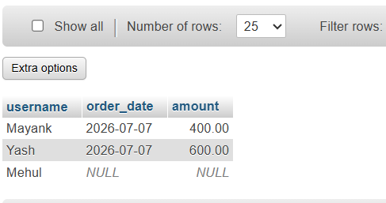

Q4 | You notice that your JOIN query between Zomato's Restaurants and Reviews tables is returning duplicate rows for some restaurants. Modify your query to eliminate duplicates and explain in one line why the duplicates were happening.<br><br><em><strong>Hint:</strong> Use DISTINCT or GROUP BY and consider the relationship between restaurants and reviews.</em>
Code | #create table Restaurant  CREATE TABLE Restaurants ( restaurant_id INT AUTO_INCREMENT, restaurant_name VARCHAR(100), city VARCHAR(50), PRIMARY KEY(restaurant_id) );  #insert record  INSERT INTO Restaurants (restaurant_id, restaurant_name, city) VALUES (1, 'Spice Villa', 'Ahmedabad'), (2, 'Pizza Corner', 'Surat'), (3, 'Burger Hub', 'Vadodara'), (4, 'South Express', 'Rajkot'), (5, 'Briyani Corner', 'Hyderabad'), (6, 'Cafe Delight', 'Gandhinagar');  ##create table Review  CREATE TABLE Reviews ( review_id INT AUTO_INCREMENT, restaurant_id INT, rating INT, review_text VARCHAR(255), PRIMARY KEY(review_id) );  #insert record  INSERT INTO Reviews (review_id, restaurant_id, rating, review_text) VALUES (1, 1, 5, 'Excellent food'), (2, 1, 4, 'Very good'), (3, 2, 5, 'Amazing pizza'), (4, 2, 4, 'Nice service'), (5, 2, 5, 'Loved it'), (6, 3, 4, 'Tasty burgers'), (7, 3, 5, 'Best burger in town'), (8, 4, 3, 'Average food'), (9, 5, 5, 'Delicious biryani'), (10, 6, 4, 'Great coffee and snacks');  #final code for apper duplicate  SELECT r.restaurant_name, rv.rating FROM Restaurants r JOIN Reviews rv ON r.restaurant_id = rv.restaurant_id;  #final code to remove duplicate  SELECT DISTINCT r.restaurant_name FROM Restaurants r JOIN Reviews rv ON r.restaurant_id = rv.restaurant_id;
Output | 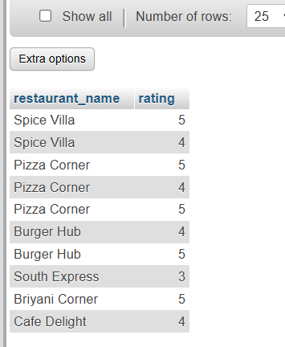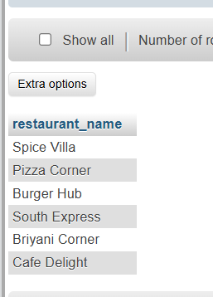

Q5 | Write two different JOIN queries on a Products and Categories table (like Flipkart) to list all products with their category names, but use different join conditions in each. Briefly explain which join condition is more efficient and why.
Code | #create table categories and insert record  CREATE TABLE Categories ( category_id INT AUTO_INCREMENT, category_name VARCHAR(50), PRIMARY KEY(category_id) );  INSERT INTO Categories (category_id, category_name) VALUES (1, 'Electronics'), (2, 'Clothing'), (3, 'Books'), (4, 'Home Appliances'), (5, 'Sports'), (6, 'Furniture'), (7, 'Beauty'), (8, 'Toys'), (9, 'Groceries'), (10, 'Footwear');  #create table products and insert record  CREATE TABLE Products ( product_id INT AUTO_INCREMENT, product_name VARCHAR(100), price DECIMAL(10,2), category_id INT, PRIMARY KEY(product_id) );  INSERT INTO Products (product_id, product_name, price, category_id) VALUES (1, 'Laptop', 55000, 1), (2, 'Mobile Phone', 25000, 1), (3, 'T-Shirt', 999, 2), (4, 'Novel', 499, 3), (5, 'Microwave Oven', 8500, 4), (6, 'Cricket Bat', 1500, 5), (7, 'Office Chair', 4500, 6), (8, 'Face Wash', 299, 7), (9, 'Toy Car', 799, 8), (10, 'Running Shoes', 2999, 10);  #Query 1 – JOIN Using on  SELECT p.product_name, c.category_name FROM Products p INNER JOIN Categories c ON p.category_id = c.category_id;  #Query 2 – JOIN Using USING  SELECT product_name, category_name FROM Products INNER JOIN Categories USING (category_id);
Output | 